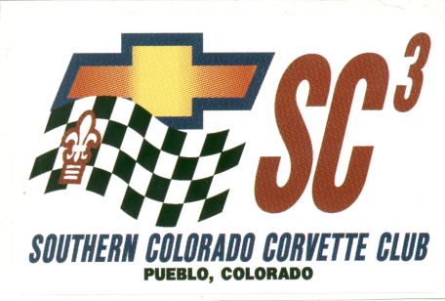
Corvette Show & Shine
Sponsored by
The Southern Colorado Corvette Club
At The Southern Colorado Gaming and Event Center
(Formerly Pueblo Greyhound Park)
Lake Avenue and Pueblo Blvd.
Pueblo, CO

Pueblo, Colorado

Saturday June 4, 2011

Time: 7:00 am to 3:00 pm. Registration: 7:00 am to 9:00 am. Award Ceremony: 3:00 pm.
Driver’s Meeting: 9:30 am Entry Fee: $15.00 for the first car and $10 for each additional car.
People’s Choice Awards: Trophies and door prizes. Judging: 10:00 am – 1:00 pm
Classes: C-1, C-2, C-3, C-4, C-5, C6, Z06, ZR1 and Custom
Concessions: Breakfast (8:00 am to 11:00 am) and Lunch and Drinks available on premises.
No admission charge to the general public.
The Corvette Show is part of a 3 in 1 show including the Southern Colorado Mustang Club and the Southern Colorado Mopar Club.

After May 21st, you may complete registration on the Show Date. Please send registration and payment to:
Southern Colorado Corvette Club the address below. Questions call 719-647-1383.

-------------------------------------------------------------------------------------------------------------------------------------
This is a standard release form. It must be signed in consideration for your participation in the Southern Colorado Corvette Club event. In consideration for my entry in the Southern Colorado Corvette Club event, for myself, my heirs, anyone participating with me, executors and administrators, waive, release for forever discharge any and all rights and claims for damages which I have or which may hereafter accrues to me against the Southern Colorado Corvette Club, it administrators, representatives, and members.
The Southern Colorado Corvette Club is not responsible for any and all damages which may be suffered or sustained to me personally or anyone participating with my entry in connection with my participation in this event.
I attest and verify that I have full knowledge of any risks involved in the event. I guarantee that any and all damages suffered by any person attending this event from my entry, is my sole responsibility.

By signing below I have read this release.

Name _______________________________________________________ NCCC # ______________

Address _____________________________________________________
City ___________________________ State _________ Zip ___________ Mail to:
SCCC
Year of Corvette ____________ Class _____________
C1: 1953-1962; C2: 1963-1967; C3: 1968-1982; C4: 1984-1996; C5 1997-2004;
C6: 2005-2010; ZO6; ZR1 and Custom: (5 or more changes from OEM) 845 South Blakeland Dr.

Date _________________ Signature ______________________________ Pueblo West, CO 81007

Your registration shall become null and void if your signature is not upon this form.

NCCC sanction #: RM-217-001 Region: Rocky Mountain

Event Chairperson: Bob Adams 9 Ibis Lane Pueblo, CO 719-560-1814
NCCC Governor: Lucky Schneberger 1000 Willocrest Drive Pueblo, CO 719 561-2045

For more information visit: www.southerncoloradocorvetteclub.com
Location Map:

